Ideation Phase
Brainstorm & Idea Prioritization Template

Date | 20 october 2026
Team ID
Project Name | StaffSync
Maximum Marks | 4 Marks

Brainstorm & Idea Prioritization Template:
Brainstorming provides a free and open environment that encourages everyone within a team to participate in the creative thinking process that leads to problem solving. Prioritizing volume over value, out-of-the-box ideas are welcome and built upon, and all participants are encouraged to collaborate, helping each other develop a rich amount of creative solutions.
Use this template in your own brainstorming sessions so your team can unleash their imagination and start shaping concepts even if you're not sitting in the same room.
Reference: https://www.mural.co/templates/brainstorm-and-idea-prioritization

Step-1: Team Gathering, Collaboration and Select the Problem Statement Before you collaborate
A little bit of preparation goes a long way with this session. Here's what you need to do to get going:

- ·’ 10 minutes to prepare
• + 2-8 people recommended
- A. Team gathering: Define who should participate in the session (HR coordinators, team managers, developers, and employee representatives) and send an invite. Share relevant information on current manual HR bottlenecks.
- B. Set the goal: Think about the problem you'll be focusing on solving in the brainstorming session: simplifying workforce administration, absence tracking, and attendance verification.
- C. Learn how to use the facilitation tools: Use facilitation superpowers to run an active, productive ideation session.

Define your problem statement

HR administrators, department managers, and enterprise employees struggle with disjointed, manual workforce management systems—such as scattered spreadsheets, paper-based leave approvals, and unverified attendance tracking—which leads to administrative delays, communication gaps, and payroll processing errors.
·’ 5 minutes

PROBLEM STATEMENT CARD:
How might we help organizations streamline employee records, automate attendance tracking and

leave approval workflows, and facilitate transparent internal communications in a single, secure, role-based platform?

Key rules of brainstorming

- Stay on topic: Focus on core HR, manager, and employee operations.
- Encourage wild ideas: Consider self-service portals, live shift clocks, and instant notifications.
- ️ Defer judgment: Every operational pain point is valuable.
- Listen to others: Build on team suggestions for approvals and security.
- Go for volume: Capture all ideas from onboarding to training tracking.
- If possible, be visual: Map user journeys for HR, Manager, and Employee gateways.

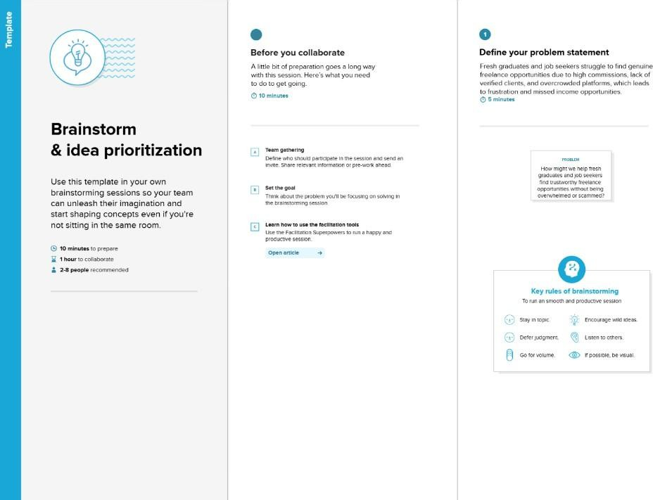

Step-2: Brainstorm, Idea Listing and Grouping

Brainstorm Ideas List

- Role-based segregated authentication (Strict gateways for HR, Manager, and Employee)
- Real-time digital shift punch terminal (Clock-in / Clock-out with live timestamping)
- Automated leave management workflow (Employee application & multi-role manager/HR approval)
- Centralized employee directory (Live CRUD operations and departmental assignment)
- Cross-role internal messaging & announcement bulletins (Organization-wide memos & notices)
- Departmental training & skill development tracker (Manager assignment and progress tracking)
- Multilingual support & live server clock (Inclusive accessibility with Hindi/English toggles)

Team Brainstorming Input (Person 1 to Person 4)

Contributor | Sticky Note 1 | Sticky Note 2 | Sticky Note 3
Person 1 (HR Lead) | Centralized employee database  with live CRUD operations | Organization-wide leave ledger & approval review | Comprehensive daily attendance auditing ledger
Person 2 (Lead Architect) | Strict JWT role-based access control (preventing role  spoofing) | RESTful API backend following strict MVC architectural pattern | Scalable MongoDB schemas with relations for users, leaves, and  attendance
Person 3 (Department Manager) | Department-filtered team directory and capacity tracking | One-click leave request approvals and rejections | Training program creation, assignment, and skill monitoring
Person 4 (Employee Rep) | Self-service shift punch terminal (Clock In / Clock Out) | Digital leave application with real-time status tracking | Real-time corporate bulletin board and profile picture customization

Group Ideas
We prioritized ideas using an Impact vs. Feasibility Matrix. High-impact and highly feasible ideas included role-based JWT authentication, centralized employee records management, and digital leave application workflows. Moderately complex features like real-time attendance shift terminals and corporate announcements were scheduled for core development, while advanced skill metrics and automated payroll integrations were marked for future extensions.
·’ 20 minutes

- TIP: Role-segregated gateways (HR Administration, Manager Operations, Employee Self-Service)
- TIP: Automated leave request submission with real-time approval/rejection updates
- TIP: Digital shift clock-in/out attendance logging with audit trail
- TIP: Real-time cross-portal corporate announcements and messaging hub

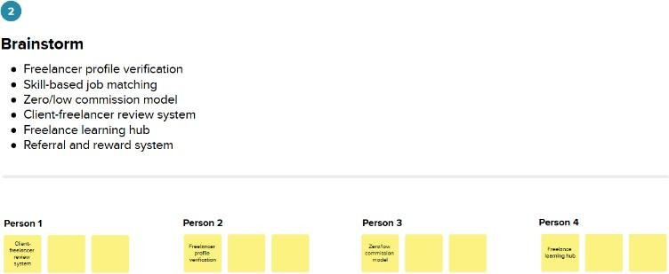

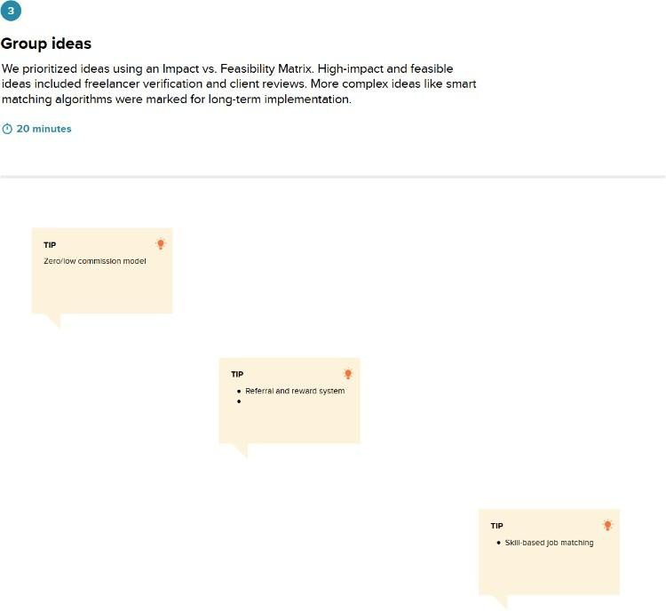

Step-3: Idea Prioritization

Prioritize

High Impact & High Feasibility (Immediate Core Rollout):
  - Role-Based Access Control (RBAC) with JWT authentication
  - Centralized Employee Directory (Add / Edit / Remove / View)
  - Digital Leave Application and Approval System

High Impact & Moderate Effort (High Value Features):
  - Digital Attendance Punch Terminal (Clock In / Clock Out with live hours)
  - Cross-Role Corporate Bulletins & Internal Memos System

Nice to Have (Future Iterations):
  - Departmental Training & Professional Development Tracker
  - Instant Multilingual Localization Toggle (English / Hindi)

  - Detailed Monthly Payroll Calculation & Attendance Export
·’ 20 minutes

